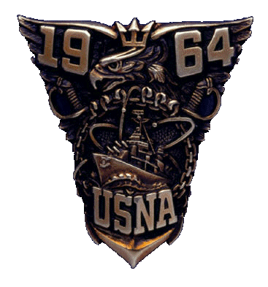
United States Naval Academy Class of 1964
C/O William H. Natter, Jr. President
2086 Generals Highway, Suite 302
Annapolis, Maryland 21401

September 28, 2011

Dear Classmates and Honorary Classmates:

Through the leadership of Jay Green, and his teammates Mike Farmer and Frank Feltham, our Class has been actively involved in numerous elements of the “Another Link in the Chain” Program (ALITC) during the past year with our “Junior Class” of 2014. In recent years, the Naval Academy Alumni Association, in concert with the Naval Academy, developed the ALITC Program to foster a link between each new Class of Midshipmen and the class that graduated 50 years before them. For the Class of 2014, their link is the “Great Class of 1964”.
Our Class ALITC Program with our Junior Class began before their members were sworn in as midshipmen. Some forty ’64 classmates and their wives participated in parent’s association welcome events for the incoming plebes all over the country. Classmates and wives were present on “Induction Day” to witness the swearing in of the Class of 2014. At the end of plebe summer, our classmates were privileged to present an honor coin, a new tradition, to each member of our junior class, upon the conclusion of an inspiring address to them by our classmate Gordon Clow about the values of Honor, Courage, Commitment and Ethical Leadership. Future events scheduled include: a Bonds of Gold Ceremony, a Service Commitment Dinner, our presence at the Class of 2014’s Ring Dance and presentation of the first set of Gold Ensign or Second Lieutenant bars to them as they receive their diplomas at graduation. We have experienced a very successful Program to date, due to the wonderful enthusiasm of our participating classmates.
The next event in our ALITC Program is the Bonds of Gold Ceremony, designed to further foster the bond between our class and our Junior Class of 2014. Our classmates and honorary classmate widows are invited to donate Class rings and/or miniatures to the Class of 2014 for the purpose of melding the ring material into the gold that will be used to produce Naval Academy class rings for the Class of 2014, thus creating a physical and everlasting “Bond of Gold” between our classes. For our honorary members of our Class, the widows of our classmates, we recognize that the ring may have significant sentimental value to you or other members of your family creating an emotional issue. We suggest this be discussed with your children, if applicable, to determine if the family wishes to honor your late husband in this way. Therefore, please do not consider this letter a request, but an invitation to become an important part of the next key ALITC Program event, if you choose to do so.
In the spring of 2012, all members of the Class of 1964 are invited to participate in the Bonds of Gold Ceremony with the Class of 2014 in Memorial Hall, when those who choose to donate rings can present them personally to our Junior Class. Mike Farmer, the Class of ’64 Ring and Crest Committee chairman attended the Bonds of Gold Ceremony for the Classes of 1961/2011. He reports that the Ceremony is a tasteful, solemn and moving experience for both classes, producing a well formed bond between the classes for ages to come. Mike has volunteered to coordinate this event for our Class. If you wish to donate a ring for this very special purpose, please let him know by email, or by mail, if you prefer, at his contact addresses listed below. Rings to be donated should be received by Mike prior to March 1, 2012.
Donations are tax deductible. The USNA Foundation will provide a letter stating the deduction has occurred. Valuation of the ring and the gifting of it is the responsibility of the donor. Appraisal of the ring should be completed before the donation takes place. We recommend that all stones be removed, and retained for use by the donor. Rings should be sent by UPS, FedEx, or USPS, covered by insurance. A signature should be required upon receipt. Mike will keep them safe until the time to present them to the Class of 2014.
We suggest ring donors provide us a brief write-up about the ring owner for use during the presentation ceremony. The description of the classmate or donor may include, as an example, information as to why the person chose to go to the Academy, what company he was in, his military and civilian career, etc. Donors, their classmates or widows will be given an opportunity to make a brief presentation describing the individual whose ring will become part of the heritage of the Class of 2014. The officers of their class will then accept the donated rings from ’64.
We will inform you of the exact date of the Bonds of Gold Ceremony to be held in April 2012 in Memorial Hall, once it is established by the Academy. The Ceremony is expected to begin at 7 p.m. and last for about an hour. Expected attendees include: a large contingent from the Class of 2014, classmates, honorary classmates and wives of 1964, Academy leadership, and ring donors who wish to attend.
We believe the importance of Bonds of Gold Ceremony is not the number of rings we donate to our Junior Class, but rather the bond we establish with them during this meaningful event of both classes. Please give this opportunity some thought and let Mike Farmer know if you’d like to be a ring donor for this important Ceremony.

Thank you for your consideration.
With Very Best Wishes,
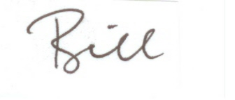
Bill Natter
President of the Great Class of 1964

Cc: Noreen Frenaye, USNA AA
Jay Green ‘64
Mike Farmer ‘64

Mike Farmer contact information and Address to send donated rings:
142 Prince George Street
Annapolis, MD 21401
Email: farmer.mike@comcast.net
Mobile: 443-480-5882

